Training Guide for Sales and Customer Support

## Background:

Based on the recent study , the food delivery/hospitality industry is incurring huge operational cost and the on-time delivery of the food is also a on-going concern . To address the problem ,there is a need for automating the process entire supply chain of food delivery right from ordering the food to the last mile delivery, thereby food delivery/hospitality industry shall achieve significant reduction in the cost and also increase the productivity , thus improving the bottom line improving the topline.

According to the survey or data available, we surmise that 60% of the US population order food online(<https://upserve.com/restaurant-insider/online-ordering-statistics/>) and there is an immense potential in tapping this market and DoorDash as a solution is deemed fit to help our customers with their operational needs and cutting down on the operational cost. The market size for this is $212 Mn with a CAGR of 35% (

[(https://www.prnewswire.com/in/news-releases/autonomous-last-mile-delivery-market-size-is-projected-to-reach-usd-84-72-billion-by-2030-at-cagr-24-4-valuates-reports-802847682.html](https://www.prnewswire.com/in/news-releases/autonomous-last-mile-delivery-market-size-is-projected-to-reach-usd-84-72-billion-by-2030-at-cagr-24-4-valuates-reports-802847682.html)) , which is very lucarative business to capitalize on.

DoorDash being one of the prominent player in the automated food delivery solution provider, shall bespoke the solution to cater to the customer’s requirements be it in terms of distance , re-routing and host of other features the customers intends to have .

To keep ourselves with the everchanging market demands, Doordash shall have the below new features in the product :

* Delivery of the goods right from origin to the last mile delivery without human intervention or minimal human intervention in case of failure.
* Build an efficient mobile or native app for the users to place the order, track the order, notifications of the delivery, secured transaction at the last mile delivery to authenticate the user.
* Remote asset management and tracking

## Market background:

Write a short description of your market and audience:

* Describe who your ideal customer is and where you believe the sales team can find these customers
  + Outline your target audience: who your potential customers are, what they look like.
  + Describe your targeted market: where you would like to roll out your product, anything specific sales need to know.
* Describe your competitors

Write a short description of your market and audience:

* Outline your target audience
* Describe your target market
* Describe your competitors

Doordash product is mainly targeted to the food delivery/hospital industries, the end customers being the users in the age group of 18-75, who shall place the food order online. There is a surge in the online food ordering and Doordash is geared up to help our customer to achieve their goals.

Doordash is designed to catered to the needs of the food and hospitality across the globe. However, Doordash shall be supported in US, Some parts of Asia. However, there are plans to increase the footprints across the globe.

There are prominent players in the market who are in direct competition with Doordash. There are around 10 players in the automated food system in the market out of which Nuro, Starship, Eliport are the major competitors to Doordash. Doordash provides flexible business model and also the capabilities/features of Doordash are the key differentiators (with more 5 patents pending for this product on Ai/ML modeling) .

## Product Background and Positioning:

Doordash is end-to-end turnkey solution which is specifically catered to the food delivery /hospitality industry. The solution can broadly be split into three parts . First, the **Mobile app** target for the **end user** whichwill be used for ordering food.

Second is the backend which is specifically designed for the operations team/customer support to track the robot, estimated time and the support team for triaging any issues or customer complaints.

The third one is the indigenous Dashdoor robot, responsible for the delivery of the product right from the origin to the destination(The robot is designed with the custom board hardware with all the sensors, GPS modems) and built in AI/ML algorithms to make smart decision on its own. However, there shall be intervention from the operations team to train the robot and to get acquainted with the stuff it needs to do.

The product aims to reduce the operational cost for their customers by 50% and increase the productivity by 30% by completely automating the task carried out by human beings, the human intervention is drastically reduced by nearly by 50%, which shall be a great saving for the organization with one time investment in Doordash product.

The main features of the product are :

1. Mobile app and the backend : The mobile app helps the user to login and order the food. The order is the recorded in the database of the Doordash delivery system’s database, the notification is sent to the user about the order placed and the estimated time of delivery.

The user logs in with his credentials using login page of the Doordash mobile app as shown in the below figure

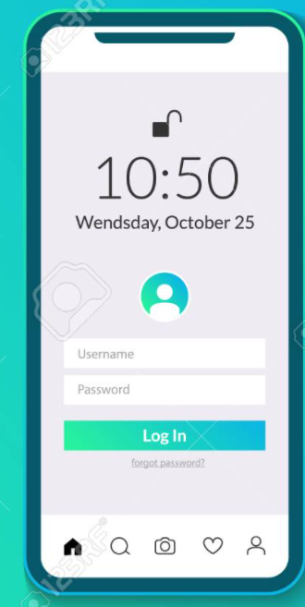

There is a recovery option of username and password, where in the user can click the forgot password option.

1. Doordash delivery system : The Doordash delivery system is the backend and all the business logic is implement in this platform. The Doordash delivery system provides the Realtime tracking, re-routing and notification features. The operations team members have access to this back-end system which has the privileges to interact with the Dashdoor robot in real time and can re-route it if there is a request from the user to do so. Also, the Doordash has built in analytics engine for the analysis of the orders received and the management make informed decisions or change strategy based on the outcome.

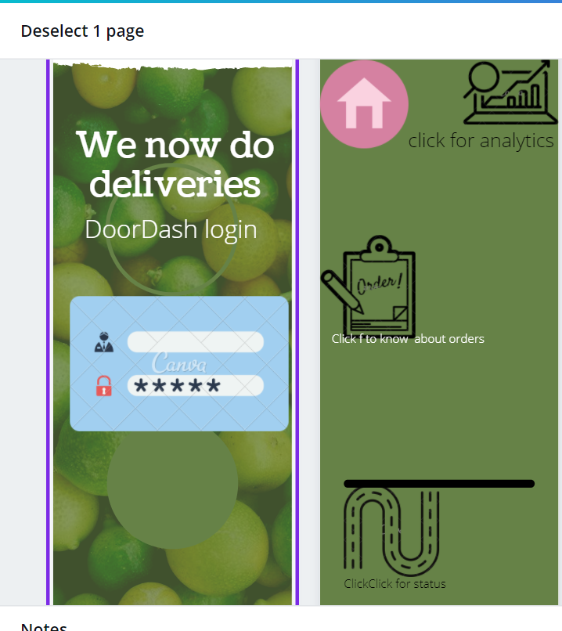

The above figure is the backend of the Dashdoor for the operation team and the customers, it has icons to know the status of the robot, analytics and robot tracking with click of respective icons.

1. Robot delivery and re-routing : This feature is responsible for the delivery of the food product and also re-routing of the address upon the request from the user in real time . The operations team member triggers this event and then the robot re-routes itself to deliver the order to the new address.

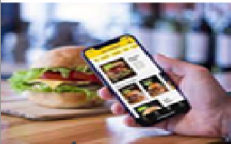

Re-route request

Acknowledgement and Notification



Doordash backend system

The user selects the re-route option with the new address, this triggers notification to the backend system, which in turn the operation team commands the robot to re-route it to the new address.

Known issues :

The re-routing is not always successful, the robot stalls if the operation team triggers for re-routing .

The user will not get updates on the re-routing and puts the user in dilemma, whether re-routing is successful. The user has to call the customer care to know about the re-routing status.

Where to find the product ?

1. Customers can find the product on webpage (<https://www.xyz.com/DoorDash/> -This is dummy URL) to buy the product .Also, you can reach us at [sales@xyz.com](mailto:sales@xyz.com) for enquiries and further
2. Dashdoor Mobile app is available on the play store/app store with the name Doordash.

## Pricing:

Currently we are supporting our customers with the managed services . The pricing of the managed services is detailed in the below table.

|  |  |  |  |  |
| --- | --- | --- | --- | --- |
| S.No | Component | Description | Cost | Remarks |
| 1 | NRE Cost for the software | This is the non-recurring engineering cost for customizing the solution | $45,0000 | Customers can avail the COTS product for $30,000* , which doesn’t involve the customization |
| 2 | Doordash Robot |  | $2,000/robot | Minimum of 100 robots shall be placed |
| 3 | AMC | This is the annual maintenance cost | $20,000 | This is the maintenance which involves the 24/7 support and 3 on-site visit of our expert to your site |

The cost of the Doordash solution is $2.65 + taxes Million for the managed services with AMC for one year, subsequently after one year, the customer can pay fixed AMC $30,000 + taxes.

However, we can offer discount of 15% to the customer if the number of the robots purchased are 150 or more and additional 10% discount upfront by signing the 5 year contract with us.